Batch: A2 Roll No.: 16010122034

Experiment 01

Grade: AA / AB / BB / BC / CC / CD /DD

Title: Data Collection and finalizing dataset from problem domain

Objective:

1. To learn how to collect the dataset

2. To learn sources of dataset

3. To assess the dataset based on Metrics to Measure Data Quality

4. To finalize the features of dataset

Course Outcome:

CO1: Learn how to locate and download datasets, extract insights from that data and present their findings in a variety of different formats.

Books/ Journals/ Websites referred:
https://www.kaggle.com/datasets/ruchi798/data-science-job-salaries?resource=download

Resources used:

Kaggle Datasets
- https://www.kaggle.com/datasets/ruchi798/data-science-job-salaries?resource=download
- Excel Sheet

Theory:

Source of dataset: Kaggle

Dimensions of dataset: 11 rows 607 columns

Summary: Chosen dataset gives information about the exact salaries of employees in different fields in different currencies along with the salaries converted into the amount in USD for uniformity in the years 2020-present. It contains details about the employee’s residence country and the company’s location. Also contains other details about the employee such as their experience level, type of employment, job title and work done remotely.

Sample View:

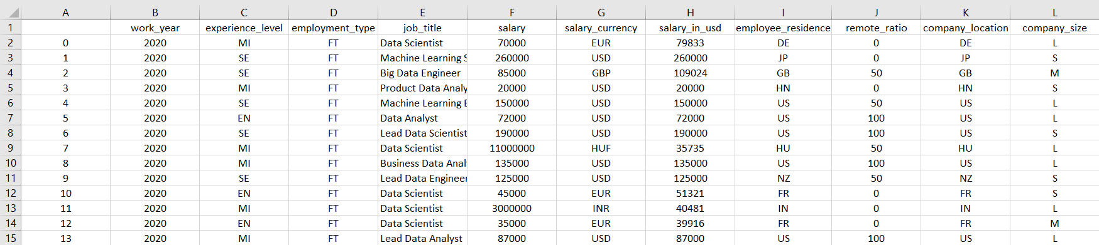

Problem domain

Salaries of jobs in Data Science domain.

Brain stormed features of Dataset

The dataset has the following features:

1)Work Year: The salary that was paid to the employee in that year (For the finalized dataset we have selected the year 2021)

2) Job Title: Employment Role

3) Experience Level: The experience level of the employee in the job

Roles:
EN Entry-level
Junior MI Mid-level
Intermediate SE Senior-level
Expert EX Executive-level
Director

4) Employment type: Type of employment (For the finalized dataset we have chosen FT as the employment type)

PT - Part-time
FT - Full-time
CT - Contract
FL - Freelance

5) Salary in USD: Salaries in different currencies converted in USD

6) Salary: Total salary paid

7) Salary Currency: Currency salary was paid in

8) Remote ratio: It is the amount of work done remotely.

0 – No remote work (less than 20%)

50 – Partially remote

100 – Fully remote (more than 80%)

9) Employee residence: Country the employee resided in

10) Company location: Country of the employer’s main office or contracting branch

11) Company size: (For the finalized dataset we have selected the company size to be M)

S – Less than 50 employees

M – About 50 – 250 employees

L – More than 250 employees

MOTIVATION FOR THE SELECTED DATASET

This Dataset gave us insight into the Real time salary figure for different Data science role along with their job experience, with the companies placed in different locations.

The salary data is provided in the respective currency and also for uniformity it is converted and presented in USD.

The dataset is from the work year 2020 till now and is updated.

Companies of three different sizes are shown – S, M and L

Although more data for companies of S and L size should have been added for a clearer picture.

SOURCE OF DATASET

https://www.kaggle.com/datasets/ruchi798/data-science-job-salaries?resource=download

SAMPLE OF FINALIZED DATASET AND ITS SOURCE

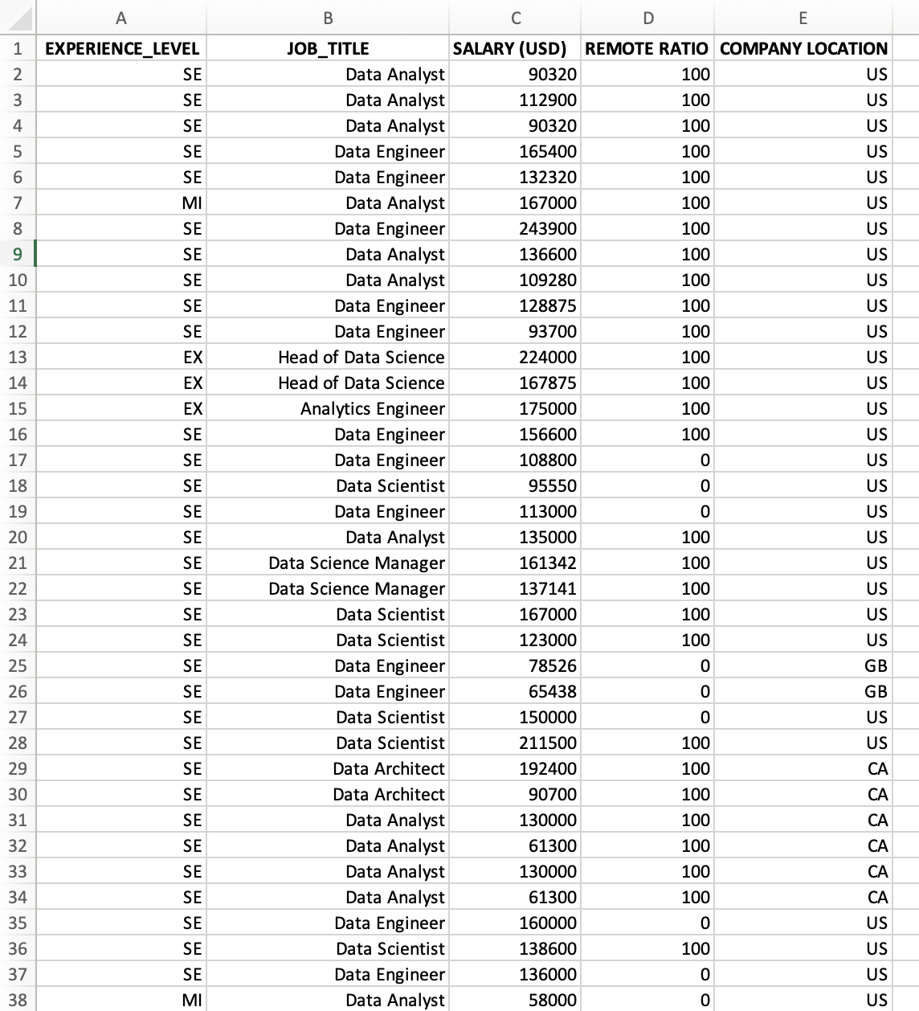

JUSTIFICATION FOR CHOOSING ABOVE DATASET

For the selected dataset the fields that we chose were

Experience level

Job title

Salary in USD

Remote ratio

Company location

We have filtered the dataset keeping the company size = M, work year = 2021 and employment type = FT

This dataset gives us an insight into the possible salary figures (in USD) for different data science roles working for a medium size (i.e about 50 – 250 employees) company.

The reason for filtering out the company size as M is that majority of the records were for a M size company.

Conclusion (Students should write in their own words):

Learnt how to locate and download datasets, assess the data and extract insights from that data and present their findings in a variety of different formats.

Post Lab Question:

Explain Role of Data in the Application Design.
Data forms the cornerstone of our product development process. It can quickly inform development priorities for enhanced user experience, improved user satisfaction and increased adoption rates. In order to keep up with the times, your designs need to be based on data

Write different types of Data with Example.

Mainly there are two types of Data:

Quantitative Data: Data that can be expressed in numbers i.e., it can be quantified. Quantitative data is discrete (values are integers or whole numbers) and continuous i.e., used to represent measurements.

Qualitative Data: Data that cannot be expressed in terms of numbers. For example: images, symbols etc. Qualitative data is nominal (do not have natural ordering) or ordinal (have natural ordering) and categorical i.e., used to represent characteristics.

